Ministry of Higher Education and Scientific research
UNIVERSITY OF kerbala
College of Veterinary Medicine

ORAL AND LARYNGEAL NECROBACILLOSIS
(Calf diphtheria)
خناق العجول

Supervisionاشراف

Assistant Professor Dr.Hayder Badri Abboud
الاستاذ المساعد الدكتور حيدر بدري عبود

By
Muntadhar Abdul Hussein Abdon
Fourth Year 2014-2015
منتظر عبد الحسين عبدون
المرحلة الرابعة 2014ـ2015

ORAL AND LARYNGEAL NECROBACILLOSIS
(Calf diphtheria)
Synopsis
Etiology Fusobacteriumnecrophorum Epidemiology Oral infection principally in calves less than 3 months old. Laryngeal involvement in older animals up to 18 months of age Clinical findings Necrotic stomatitis: Fetid breath and necrotic ulceration of mucosa of cheek Calf diphtheria: Fetid breath. Inspiratory dyspnea, necrotic lesions on arytenoid cartilages Lesions: Necrosis at site of lesion Treatment Antimicrobials. Tracheostomy may be required to allow breathing with necrotic laryngitis Control None specific*(1&8)

Calf diphtheria:
The term 'oral necrobacillosis' is applied to infections of the mouth and larynx with Fusobacteriumnecrophorum. It includes calf diphtheria, in which the lesions are largely confined to the larynx and pharynx, and necrotic stomatitis, in which the lesions are restricted to the oral cavity. They are considered together because the essential lesion and infection are the same in both instances.*(2,5&8)

ETIOLOGY
F. necrophorum is present in large numbers in the lesions and is considered to be the causative agent, probably aided by prior injury to the mucosa. In the case of the laryngeal disease, the point of entry is thought to be contact ulcers in the mucosa caused by repeated closure of the larynx.! Both F. necrophorum subsp. necrophoru111 (biovar/biotype A) and F. llccrophoru111 subsp. fundulifonne (biovar/biotype B) are associated with the disease.*(8)
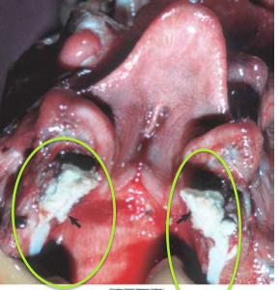

Figure 1- Secondary infectious by Fusobacteriumnecrophorum following trauma or viral infection like IBR.
- Can also occur as part of oral necrobacillosis in calves and swine
- Exuberant plaques of ulceration covered by fibrinonecrotic exudate.
- Caseous necrosis

EPIDEMIOLOGY
Occurrence The disease has no geographical limitations but is more common in countries where animals are housed in winter or maintained in feedlots. In the United States, infections involving the pharynx and larynx appear to be more prevalent in the western states than in other sections of the country. It is a common disease in
feedlots in yearling cattle, often in company with papillomatosis of the larynx.1 There is also a difference in age incidence, necroti stomatitis occurring mainly in calves 2 weeks to 3 months of age, while laryngeal infections commonly affect older calves and yearlings. Although the disease is more common in housed or penned animals, it can occur in animals running at pasture.2-4 The disease is seen commonly only in cattle but has been observed in sheep and goats.S,6 Laryngeal chondritis has been described in Texel sheep, which may be predisposed to the disease because of anatomical factors, namely the short head of the breed? This may affect the shape of the larynx or its relationship to adjacent tissues.*(1&8)
Transmission
The causative bacterium is a common inhabitant of the environment of cattle and under lU1sanital)' conditions the infection may be spread on dirty milk pails and feeding troughs. Entry through the mucosa is probably effected through abrasions caused by rough feed and erupting teeth. The difficulty of reproducing the disease and the irregularity of its occurrence, even when F. necrophorumis known to be present, suggests the pOSSibility of etiological factors presently unknown.*(7&8)

Risk factors
Animals suffering from intercurrent disease or nutritional deficiency are most susceptible and the incidence is highest in groups kept in confined quarters under unsanitary conditions. *(5)
PATHOGENESIS
F. necrophorum is a normal inhabitant of the oral cavity and causes inflammation and necrosis following injury of the mucosa of the oral cavity, pharynx, and larynx. Edema and inflammation of the mucosa of the larynx results in varying degrees of closure of the rimaglottidis , and inspiratory dyspnea and stridor. The presence of the lesion causes discomfort, painful swallowing and toxemia. Extension of the lesion to the arytenoid carti1ages will result in laryngeal chondritis? Involvement of the cartilage will usually result in delayed healing or failure to recover completely. *(8)

CLINICAL FINDINGS
In describing the clinical findings, a distinction must be made between calf diphtheria characterized by involvement of the larynx and the more common necrotic stomatitis. In the former, a moist painful cough accompanied by severe inspiratory dyspnea, salivation, painful swallowing movements, complete anorexia, and severe depression are the characteristic signs. The temperature is high (41°C; 106°F), the pharyngeal region may be swollen and painful on external palpation, and there is salivation and nasal discharge. The breath has a most foul rancid smell. Examination of the pharynx and larynx by visual inspection through the oral cavity with the aid of a speculum positioned over the base of the tongue will often reveal the lesions. Visual inspection of the larynx is relatively easy and simple with the aid of a ,cylindrical plastic speculum placed over the base of the tongue in calves and adult cattle. The larynx can be viewed directly and illuminated with a strong source of light. A flexible fiberoptiscope is also useful when available and is necessary for examination of the equine larynx. The mucosa of the larynx and glottis are usually edematous, inflamed and a necrotic lesion is usually present and visible on one or both arytenoid cartilages. The opening of the larynx is commonly reduced due to the edema and inflammation. Careful visual inspection of the larynx during inspiration may reveal that the lesion extends into one or both vocal cords. The examination usually causes considerable discomfort, anxiety and the production of purulent or blood-stained saliva. Death is likely to occur from toxemia or obstruction to the respiratory passages on days 2-7. Most affected calves die without treatment but only a small proportion of calves in a group are usually affected. Spread to the lungs may cause a severe, suppurative bronchopneumonia. In calves affected with necrotic stomatitis, there is usually a moderate increase in temperature (39.S-40°C; 103-104 OF), depression, and anorexia. The breath is foul and saliva, often mixed with straw, hangs from the mouth. A characteristic swelling of the cheeks may be observed posterior to the lip commissures. On opening the mouth this is found to be due to a deep ulcer in the mucosa of the cheek. The ulcer is usually filled with a mixture of necrotic material and food particles. An ulcer may also be present on the adjacent side of the tongue and cause severe swelling and protrusion of the tongue. In severe cases the lesions may spread to the tissues of the face and throat and into the orbital cavity. Similar lesions may be present on the vulva and around the coronets, and a spread to the lungs may cause fatal pneumonia. In other cases death appears to be due to toxemia.*(6&8)

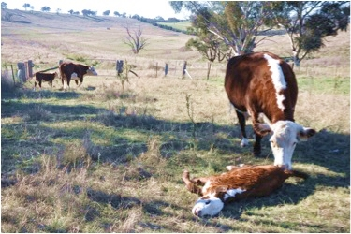
Figure 2 - One affected calf died suddenly three weeks after antibiotic therapy was instigated,
while the other recovered
CLINICAL PATHOLOGY
Bacteriological examination of swabs from lesions may assist in confirming the diagnosis.
Necropsy findings
Severe swelling, due to edema and inflammation of the tissues surrounding
the ulcer, is accompanied by the presence of large masses of caseous material. Occasionally, lesions similar to those in the mouth, pharynx, and larynx may be found in the lungs and in the abomasum. Microscopically, areas of coagulation necrosis are bordered by large numbers of neutrophils and filamentous bacteria.*(3&8)

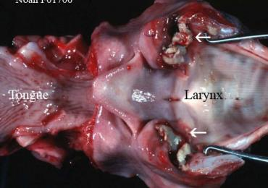
Figure 3Laryngeal infection with the bacteria Fusobacteriumnecrophorum results in the development of lesions throughout the larynx, causing painful, difficult breathing and a reluctance to eat.

*REFERENCES
1. Jensen R et a!.1981; Vet PathoI 18:143.
2.lGngman HE, Stansbury WM. North Am Vet 1944; 25:671.
3. Lovell R. Vet Rec 1945; 57:179.
4. Sutherland AK. AustVet J 1950; 26:238.
5.DiplockPTVetInsp NSW 1958; 51:53.
6.Yeraham I, Elad D. JVet Med B 2004; 51:46.
7. Lane JG et a!. Vet Rec 1987; 121:81.
8.VETERINARY MEDICINE A textbook of the diseases of cattle, horses, sheep, pigs and goats
TENTH EDITION, O. M. Radostits,C.C.Gay, K. W. Hinchcliff P.& D. Constable

