Ministry of Higher Education and Scientific research
UNIVERSITY OF karbala
College of Veterinary Medicine

FOOT ROT in SHEEPand GOAT
تعفن الحافر في الماعز والاغنام

Supervisionاشراف

Assistant Professor Dr.Hayder Badri Abboud
الاستاذ المساعد الدكتور حيدر بدري عبود
By

Ameer Emad Abd al-Hussian
Fourth Year 2014-2015
امير عماد عبد الحسين
المرحلة الرابعة 2014-2015

What is footrot
Footrot is a contagious bacterial disease of sheep and goats, caused by the organism Dichelobacter nodosus (D. nodosus) in association with a number of other bacteria.
There are many strains of D. nodosus and they vary in the severity of the disease they cause. In an infected flock, several strains of D. nodosus may be present. For regulatory purposes, footrot infection is classified as either benign or virulent at the flock level.
With full expression, virulent footrot is a severe, debilitating disease with significant economic loss from reduced wool growth and quality, poor ewe fertility, poor growth rates, losses from blowfly strike, and reduced value of sale sheep. In infected flocks, there are also significant costs associated with the control of the disease. (1)
Footrot in goats
Footrot is a notifiable disease in goats, even if they are run on a property with no sheep.
Footrot infection in goats does not behave in the same way as in sheep. It is impossible to distinguish between the benign and virulent strains of footrot by clinically examining a number of goats.
The benign forms of footrot may cause severe underrunning in goats, and the virulent forms may cause only inflammation between the claws, with little or no underrunning. In goat herds, a laboratory test may be used to assist in differentiating between benign and virulent footrot.
Goats can carry the virulent form of footrot between properties and can infect sheep under suitable environmental conditions.(1)

Development of footrot
The development of footrot depends on both infective and environmental factors.(1)

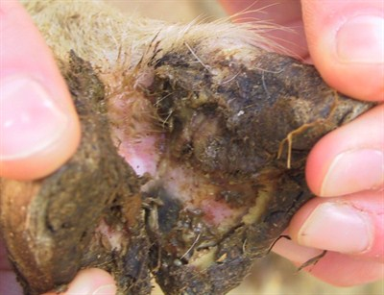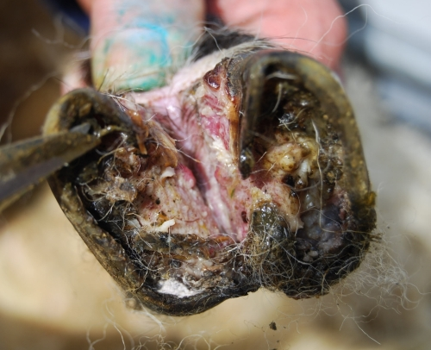
Figure 1Early case of footrot with infection spreading under the horn tissue so that horn becomes separated from the sole. This foot must not be trimmed.
Figure 2 Footrot occurs when scald is followed by further bacterial infection by Dichelobacter nodosus, which invade the deeper structures of the foot leading to inflammation and tissue damage. There are different strains of this bacterium which have varying virulence. The combination of the two bacteria causes separation of the horn from the underlying structures of the foot, which may spread across the sole and up the wall of the hoof in serious cases.

Infective factors
The bacterium D. nodosus:
must be present for footrot to develop;
will not survive in the environment for more than 4 days even under the most favourable conditions;
may persist for many years in the feet of infected sheep, even under dry conditions;
will not invade dry healthy feet; (1)
Epidemiology
The disease is seen year round, but the prevalence is
usually higher when pens are wet and muddy. Pen
conditions can be particularly severe when ground
alternates between wet mud and manure to frozen
clods can be particularly severe. Although all ages are
susceptible, the disease is most commonly seen in cattle
of weaning age and older. Morbidity can vary from one
or two animals affected in the herd to large outbreaks of
over 25 percent affected.(6)

Strain differentiation
There are many strains of D. nodosus and they vary in the severity of the disease they cause. :
Benign strains
Usually cause lesions that are mild and resolve as conditions dry off, without treatment. There is usually minimal economic loss. Infection with benign strains is termed ‘benign footrot’.
Virulent strains
Usually cause severe lesions associated with lameness, loss of production and, in severe cases, deaths. Lesions can become chronic and cause deformities of the hooves. Infection with virulent strains is termed ‘virulent footrot’.
The effect of the current environmental conditions on the expression of footrot (development of lesions) in a flock must always be considered when investigating lame sheep. A differentiation between benign and virulent footrot may not be possible based on only one inspection of a mob, depending on the pasture conditions. Flocks may be placed under quarantine for suspicion of footrot if a government veterinarian believes that further inspections are required. (1)
Symptoms
Foot scald and footrot result in lameness, reduced
weight gain, decreased milk and wool production,
and decreased reproductive capabilities as severely
infected animals are reluctant to move in order to feed.
Affected animals often carry the affected leg or lie
down for extended periods, rubbing off the wool/hair
on their flanks, brisket, and knees. These conditions
result in production losses, treatment and prevention
costs, premature culling, and reduced sale value of
infected animals. Other diseases that are sometimes
confused with footrot are foot abscesses, laminitis
(founder), corns, foreign bodies or traumatic injuries.(3)
Diagnosis
Diagnosis of foot rot is made by observing the animal and physically examining the foot for the characteristic gross lesions. Cattle producers often diagnose any lameness associated with foot swelling as foot rot, but a more careful examination may reveal other causes of the swelling and lameness, such as injury or foreign bodies.(4)
Differential Diagnosis
Trumatic lesions,Hoof growth abnormalities,Laminitis,Stanle foot rot
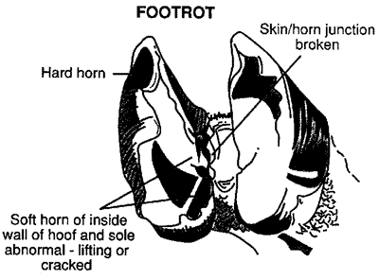

Treatment Options
Administration of injectable antibiotics or sulfas and local treatment of the foot lesion are necessary for best results. Immediate treatment as soon as possible after the onset of swelling and lameness will give excellent recovery in 2 to 4 days. When treatment is delayed for a few days after the onset of signs, severe lesions may develop and cause an extended recovery period.Local treatment includes scrubbing the lesion, removing all dead tissue, and applying any suitable topical antibacterial preparation. It should be secured with a pad and bandage that can be left on for several days. A wet pack of 5 percent copper sulfate solution also is inexpensive and effective(5)
Prevention• Cull highly susceptible animals and enhance selective breeding for resistance to foot rot.
• Trim hooves regularly. Trimming prevents hoof overgrowth, which creates an environment for
foot rot.
• Quarantine animals for several weeks after they arrive.
• Check animals for foot lesions before purchasing.
• Give animals a footbath upon returning from shows or after purchasing, and prior to their reentry
into the herd.
• Vaccinate sheep as a preventive tool for foot rot. A vaccine for foot rot in sheep is available.
The Food and Drug Administration does not approve this vaccine for use in goats.(2)

Source | Prevention
Purchase | Examine feet before buying, look for lameness and signs of treatment, footbath on arrival, isolate until sheep go through spring with no sign of footrot.
Road | Check fences, don't use for 7 days after other sheep, footbath after use if risk, stop sheep straying
Strays from neighbours | Check fences, catch and examine strays promptly, footbath and isolate infected mob if risk
Stray in neighbours | Ask neighbour not to return over fence, collect, check and footbath the stray, fix fences
Truck or saleyard | Use clean truck, footbath on arrival, isolate until sheep go through spring with no sign of footrot.
(3)
References
(1) written by John Seaman and Marilyn Evers, both former Senior Veterinary Officers with NSW DPI
(2)ALABAMA A&M AND AUBURN UNIVERSITIES
(3) Department of Environment and Primary Industries
(4)Business and industry portal https://www.business.qld.gov.au/industry/agriculture/animal-management/disaster-recovery-for-livestock-farms/flood-affected-animals/foot-diseases/flood-cattle-foot
(5)Nuflor Florfenicol http://www.nuflor.com/diseases/fr-frp.asp
(6) Prepared by Grant Dewell, DVM, PhD, Extension
Veterinarian and Jan K. Shearer, DVM, MS.

