Ministry of Higher Education and Scientific Research

University of Kerbala
College of Veterinary Medicine

Mange in farm animal

الجرب في الحيوانات الحقليه

Supervision by
بأشراف
Assistant Professor
Dr. Hayder Badri Abboud
الأستاذ المساعد الدكتور حيدر بدري عبود

By

Basheer Sameer Jawad
Fourth year 2014-2015
بشير سمير جواد
المرحله الرابعة 2014-2015

Introduction :
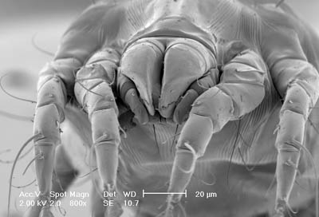
Mange is a class of skin diseases caused by parasitic mites. Since mites also infect plants, birds, and reptiles, the term "mange" or "the mange", suggesting poor condition of the hairy coat due to the infection, is sometimes reserved only for pathological mite-infestation of nonhuman mammals. Thus, mange includes mite-associated skin disease in domestic animals (cats and dogs), in livestock (such as sheep scab), and in wild animals (for example, coyotes, cougars, and bears). Since mites belong to the arachnid subclass Acari (also called Acarina), another term for mite infestation is acariasis.[6]
Mange, also known as scabies are and sarcoptic mange, is caused by a animal’s reaction to mites that invade the surface, or burrow into your animal’s skin. Despite what you may think, mites are not insects; they are more like a microscopic spider that cannot be seen with the naked eye. [1]There are several varieties of mites (sarcoptes scabiei), each with a different name and preference for a specific host animal (cow, pig, sheep, goat, etc). For information about Cattle Mange, Bovine Mange, Ovine Mange, and Caprine Mange, please see specific descriptions at the base of this page. Once a mite gets into or onto an animal’s skin, the motion of this little "bug" makes the animal’s skin extremely itchy. Actually, the mite itself isn’t responsible for most of the skin damage that results from sarcoptic mange. In an effort to scratch their hides, animals rub themselves fiercely against rough surfaces, causing hair loss, lesions, blisters and, most likely, infection. So, in order to effectively treat mange, you must simultaneously manage the animal’s itch, their wounded skin and potential healing complications. Animal mite problems are most common in the autumn and winter (when animals are typically housed for long periods of time), but can happen year round. Tell-tale signs of sarcoptic mange are itch, rash and areas of thickened skin, especially is there is not evidence of lice. If you suspect that your cow, sheep, goat or pig has sarcoptic mange, the diagnosis can easily be confirmed by any veterinarian. Your vet will take small skin samples and examine them under a microscope to look for mites.[2][6][7][10]

Types of mange:

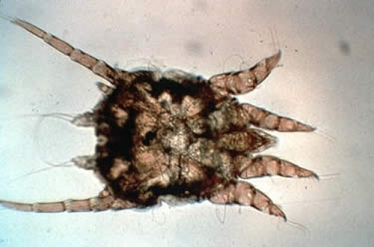
Psorergatic Mange (Itch Mite)
Psorergates how has been reported in cattle in the USA, Canada, and South Africa. Affected animals show mild, patchy alopecia and pruritus. The disease does not cause significant economic losses; thus, animals are usually not treated. Several dips and injectable ivermectins and milbemycins are effective in controlling this infestation.[5][3]
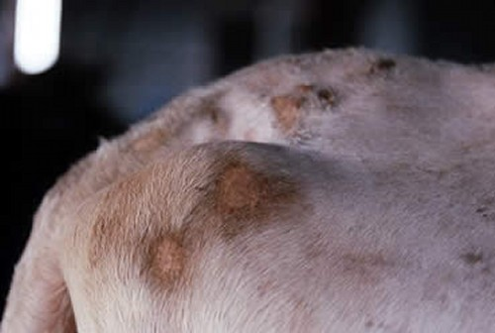
Demodectic Mange
Demodex bovis is transferred from cow to calf while nursing and may cause considerable damage to hides. Pruritus is absent. Lesions consist of follicular papules and nodules, especially over the withers, neck, back, and flanks. Ulceration, abscesses, and fistulae can develop due to follicular rupture or secondary infection. Diagnosis is made by deep skin scrapings. Bovine demodicosis usually is benign, although the course may extend for many months. Recovery is usually spontaneous; consequently, treatment is rarely done. Trichlorfon dips (2%) every other day for[5][6]

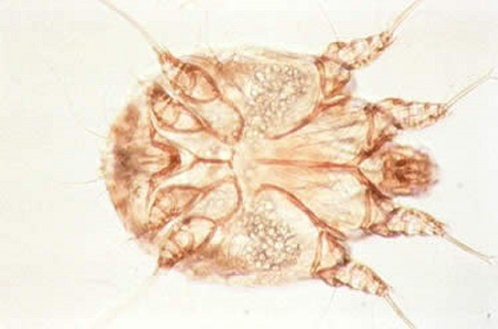
Chorioptic Mange (Leg Mange)
This reportable disease, caused by Chorioptes b ovis, does not affect humans. It is the most common type of mange in cattle in the USA; it is more prevalent during the winter and often spontaneously regresses in summer. The pastern areas of the legs are preferred sites for the mites. A high proportion of cattle can be infested without showing clinical signs. Lesions start as papules, crusts, and ulcerations on the legs and can spread to the udder, scrotum, tail, and perineal area. [9]

Psoroptic Mange
This reportable disease, caused by Psoroptes ovis, does not spread to humans. It is seen in range and feedlot beef cattle from the central and western states of the USA, with the largest numbers of outbreaks reported from Texas, New Mexico, Oklahoma, Kansas, Colorado, and Nebraska. Intense pruritus usually begins on the shoulders and rump; papules, crusts, excoriation, and lichenification are seen. Lesions may cover almost the entire body; secondary bacterial infections are common in severe cases. Death in untreated calves, weight loss, decreased milk production, and increased susceptibility to other diseases can occur.[5]

Sarcoptic Mange (Scabies)
This very contagious disease is spread by direct contact or indirectly by fomites. The causative mite,Sarcoptes scabiei var bovis, can be transmitted to humans and is a reportable disease. Lesions start on the head, neck, and shoulders and can spread to other parts of the body; pruritus is intense. Papules develop into crusts, and the skin thickens and forms large folds. The whole body may be involved in 6 wk. Diagnosis is made by deep skin scrapings, skin biopsy, or response to therapy. Treatment is as for psoroptic mange[3]

Clinical Signs :
Clinical signs do not occur for 3-6 weeks after infection with the mite. The primary signs of sarcoptic mange are similar for all species as follows :[2][6][9]
- Intense pruritus (itchiness) with self-trauma - scratching, biting
- Hairloss
- Papules
- Crusts
- Grazes on the surface of the skin
- Secondary bacterial infection
- Thickening of the skin (in chronic cases)
- Location of skin lesions is widespread - including
  - Cattle - the neck and sacral region
  - Dogs - the abdomen, chest, ears and legs - especially the elbows and hocks.
  - Horses and ponies - the head and neck
  - Pigs - the back
  - Rabbits - the face and ears
  - Sheep and goats - the face and ears
- Weight loss
- Enlarged lymph nodes
- General debilitation
- Humans[9]
  - Papules - especially on the arms or midriff (trunk)
  - Itchiness
Complications:
Bacterial infection may occur as a secondary consequence of Sarcoptic mange.
Diagnosis
Diagnosis is made by examination of deep skin scrapings and identifying mites, eggs or mite feces. Numerous samples are required to be sure to obtain a positive sample and false negative findings are frequently reported because of the "hit-or-miss" nature of sampling. Sometimes mites or their eggs may be found in fecal samples as well.[2]

Histopathology :
of skin - best if take an undisturbed papule to section - mites, eggs or mite feces may be found, along with infiltrations of eosinophils, macrophages, neutrophils, and perivascular aggregates of lymphoid cells.[9][6]

Treatment
Several treatments are available for the treatment of Sarcoptic mange including
- The following acaricides which kill the mites:
  - Amitraz
  - Benzyl benzoate
  - Bromocyclen
  - Fipronil
  - Ivermectin
  - Milbemycin
  - Monosulfiram
  - Phosmet
  - Rotenone
Some of these do not have product licenses for use in all species, and some can be toxic eg ivermectin is toxic to Collies. Animals with long haircoats may have to be clipped .
The environment should also be treated in case mites have dropped off into bedding or floor coverings.
- The itchy pruritus can be controlled using anti-inflammatory drugs eg corticosteroids.
- Antibiotics may be needed if secondary bacterial infection is present
- Antiseborrhoeic shampoos are also helpful to cleanse the skin
All animals in a household, stables or farm should be treated.[10][6]

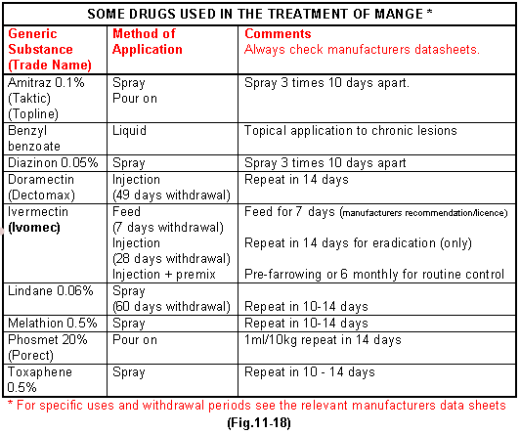
Control:
If you have an animal that is infected with mites, try to separate them from other animals as much as possible during the healing period. Most mites cannot live away from their host and only spread when an infected animal has direct contact with another. Diligently clean any shared living areas (stalls), and add fresh bedding before reusing the stalls for new animals. Additionally, disinfect share grooming tools before using them on uninfected animals.[6]
References :
1-http://www.merriam-webster.com/dictionary/Mange
2-http://www.thepetcenter.com/exa/mites.html
3-http://www.aardora.com/animal-health/farm-skin-problems/mange
4- http://www.provet.co.uk/petfacts/healthtips/sarcoptes.htm
5-http://www.merckmanuals.com/vet/integumentary_system/mange/mange_in_cattle
6http://en.wikipedia.org/wiki/Dorland%27s_medical_reference_works
7- http://medusanews.com/diseases-and-conditions/dermatology/demodicosis.html
8- http://www.ncbi.nlm.nih.gov/pmc/articles/PMC1879511
9- http://www.aafp.org/afp/1998/0915/p873.html
10- http://zipcodezoo.com/Animals/D/Demodex_folliculorum/

