Ministry of Higher Education and Scientific research
UNIVERSITY OF kerbala
College of Veterinary Medicine

nutritional diarrhea in calf
الإسهال الغذّائي في العجلِ

Supervisionاشراف

Assistant Professor Dr.Hayder Badri Abboud
الاستاذ المساعد الدكتور حيدر بدري عبود
By
Salwan Jawad Sahib
Fourth Year 2014-2015
سلوان جواد صاحب
المرحلة الرابعة 2014-2015

Introduction
Calf diarrhea is the single most important cause of death in
milk-fed calves. Even when calves survive, the increased
labor requirements for their caring, together with veterinary
and drug bills, make scours a costly problem for calf rearers.
Furthermore, their potential productivity is likely to be
decreased by setbacks in early life.
The causes of scours, particularly in calves under three weeks
of age, are complex. There is usually no one single cause,
with contributing factors being calf management, diet, the
environment and the presence of pathogens. Prevention and
early treatment with fluid replacement (electrolyte therapy)
can avoid unnecessary use of antibiotics ⁽¹⁾.
Clinical signs
- dry muzzle, thick mucus appearing from the nostrils .
2. very firm faeces .
3. refusal of milk .
4. a tendency to lie down .
5. a high body temperature (over 39.3.C). ⁽²⁾

very firm faeces .^{(3).} tendency to lie down .^{(4).}
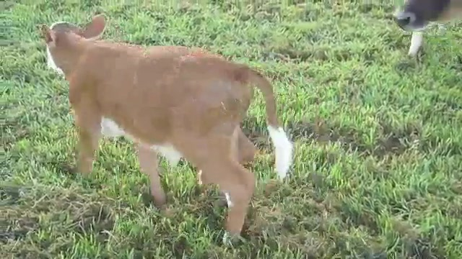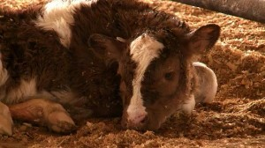
Causes
Are best defined as flaws or gaps in management. Inadequate nutrition
, exposure to severe environment, insufficient attention to the newborn calf
, or a combination of these are often involved in scours outbreaks
The most commonly encountered noninfectious problems
include:
- Inadequate nutrition of the pregnant dam, particularly
during the last third of gestation. Both the quality and
quantity of olostrums are adversely affected by not meeting
the energy and protein requirements of the pregnant dam.
Deficiencies in vitamins A and E, and trace minerals have
been associated with greater incidence of calf scours.
For more detailed information see extension publication
- Inadequate environment for the newborn calf. Mud,
overcrowding, contaminated lots, calving heifers and cows
together, wintering and calving in the same area, storms,
heavy snow, cold temperatures and rainfall are all stressful
to the newborn calf and increase its exposure to infectious
agents. The wet and chilled (hypothermic) newborn calf
experiences a loss of body heat, becomes severely stressed,
and lacks the vigor to nurse aggressively and receive
adequate olostrums early in life ⁽⁵⁾.
Prevention
The ration of the pregnant female should be balanced in
energy, protein, minerals, and vitamins. Care should be given
to adjust the nutritional requirements during cold/inclement
weather, and to keep in mind that pregnant replacement
heifers have not reached their mature size. Particular care
must be taken to provide them with sufficient feed energy for
maintenance and growth. Failure to meet energy needs will
not only result in a weak calf at birth, but also contributes
to increased dystocia (difficult calving), delayed return to
estrus, and lowered conception rates. Best results occur when
replacement heifers are wintered and calved in advance of,
and separate from, the mature cow herd. Special attention
should be given to energy deficiencies and/or vitamin A
and E shortages ⁽⁶⁾.

Treatment
important preventive measures can be taken and therapy can be started before an etiologic diagnosis has been established. Treatment includes fluid therapy for water and electrolyte replacement and correction of acid-base disturbances, alteration of the diet ^{(7).}.
Reference
1. Charles L. Stoltenow, DVM Lani L. Vincent, DVM, MS
Diplomate ACVPM, Extension Veterinarian Pathologist NDSU Veterinary Diagnostic Laboratory

2. AS-776 (Revised) JANUARY 2003 North Dakota State University Fargo, North Dakota 58105

3.&4. Picture about nutritional diarrhea by Walter Gruenberg, DrMedVet, MS, PhD, DECAR, DECBHM

5. Charles L. Stoltenow, DVM Lani L. Vincent, DVM, MS
Diplomate ACVPM, Extension Veterinarian Pathologist NDSU Veterinary Diagnostic Laboratory

6. Diarrhea in neonatal ruminant August 2014 by Walter Gruenberg, DrMedVet, MS, PhD, DECAR, DECBHM
7.Treatment of nutritional diarrhea in calf by Dr. Jon .

