Ministry of Higher Education and Scientific research
UNIVERSITY OF karbala
College of Veterinary Medicine

traumatic reticular peritonitis
التهاب الشبكيه الكلومي

Supervisionاشراف

Assistant Professor Dr.Hayder Badri Abboud
الاستاذ المساعد الدكتور حيدر بدري عبود
By
Hani Ali Yousife
Fourth Year 2014-2015
هاني علي يوسف
المرحلة الرابعة 2014-2015
Traumatic Reticuloperitonitis (Hardware Disease) in Cattle

Introduction
Traumatic reticuloperitonitis, or TRP, is a relatively common disease in adult cattle caused by the ingestion and migration of a foreign body in the reticulum. Cattle are more likely to ingest foreign bodies than small ruminants since they do not use their lips for prehension and are more likely to eat a chopped feed. The typical foreign body is a metallic object, such as a piece of wire or a nail, often greater than 2.5 cm in length (Fig. 1 & 2 )
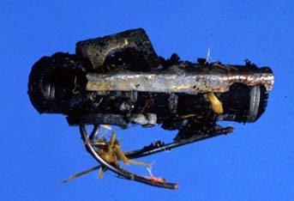 | 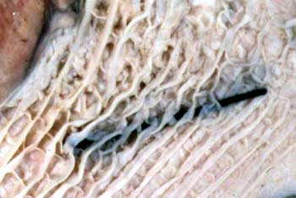
Figure 1. Metal door spring removed from a cow’s reticulum (image courtesy of Noah’s Arkive, University of Georgia). | Figure 2. A nail is embedded in the mucosa of the reticulum (image courtesy of Noah’s Arkive, University of Georgia).

Etiology
Swallowed metallic objects, such as nails or pieces of wire, fall directly into the reticulum or pass into the rumen and are subsequently carried over the ruminoreticular fold into the cranioventral part of the reticulum by ruminal contractions. The reticulo-omasal orifice is elevated above the floor, which tends to retain heavy objects in the reticulum, and the honeycomb-like reticular mucosa traps sharp objects. Contractions of the reticulum promote penetration of the wall by the foreign object. Compression of the ruminoreticulum by the uterus in late pregnancy and straining during parturition increase the likelihood of an initial penetration of the reticulum and may also disrupt adhesions caused by an earlier penetration.(6)

The classic signs associated with TRP are consistent with an acute, localized peritonitis and include anorexia, fever, tachypnea, and an arched stance with abducted elbows (indicating cranial abdominal pain) (Fig. 3) . However, not all cattle develop acute peritonitis; a significant population of affected cattle develops chronic or subclinical TRP that is not as easily diagnosed as acute TRP. Clinical signs associated with chronic peritonitis include anorexia, unthriftiness, decreased milk production, rumen hypomotility, and a change in manure consistency. Laboratory tests can be helpful in distinguishing cases of chronic TRP from other gastrointestinal diseases and are more accessible to veterinarians than other diagnostic tests, such as survey radiology or contrast radiography of the reticulum. The most appropriate laboratory tests for diagnosing TRP are the complete blood count (CBC), serum biochemical profile, and abdominocentesis.(1)
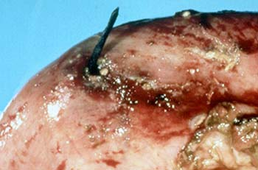
Figure 3. A nail has penetrated the reticulum, causing traumatic reticuloperitonitis (hardware disease) and the death of this cow (image courtesy of Noah’s Arkive, University of Georgia).
Laboratory Testing
Complete blood count – The CBC in a cow with TRP can vary depending on whether the peritonitis is acute or chronic and localized or diffuse. In general, cattle with persistent purulent inflammation have leukocyte counts ranging from 4,000-15,000/µL, with neutrophilia. Although lymphocytes are the predominant leukocyte circulating in healthy cattle, endogenous corticosteroid release secondary to stress may cause lymphopenia by cell redistribution; circulating lymphocytes do not re-enter the lymphatics but become sequestered in lymphoid tissue and bone marrow. (7)
Some cattle with acute, localized peritonitis will have CBCs within normal reference intervals, while others will have a degenerative left shift (band neutrophils outnumbering segmented neutrophils). Cattle with acute diffuse peritonitis will also have a degenerative left shift. In chronic cases, a mature neutrophilia is common . (1)
Serum biochemical profile – The most common chemistry abnormality associated with TRP is hyperproteinemia with a hyperglobulinemia. Some authors suggest that a total serum protein concentration greater than 10 mg/dL is highly suggestive of TRP.^{2,5} In one study of cattle suspected of having TRP that also had a total plasma protein concentration of 100 g/L (10mg/dL) had an 83% chance of having TRP, 83% of the cattle with a total plasma protein concentration of 10 mg/dL had TRP. (5)
Other chemistry abnormalities associated with TRP may include hypochloremia, hypokalemia, and metabolic alkalosis; these abnormalities occur secondary to ruminal hypomotility and/or vagal indigestion. Hypochloremic metabolic alkalosis may occur due to sequestration of hydrochloric acid in the rumen caused by rumen stasis or vagal indigestion. Hypokalemia is caused primarily by anorexia, but may be potentiated slightly by ion exchange caused by the alkalosis and/or abomasal reflux into the rumen. With alkalosis, intracellular H⁺ ions can be exchanged for extracellular K⁺ ions, decreasing serum potassium concentrations. This effect is minor compared to the K⁺ ion shifts associated with acidosis. (7)
Abdominocentesis – Normal peritoneal fluid of an adult cow is straw-colored, clear, and odorless. Protein and fibrinogen concentrations can vary from 1.0-3.0 g/dL and 100-500 g/dL, respectively. The nucleated cell count should be less than 10,000 cells/µL. The majority of nucleated cells are non-degenerate neutrophils and mononuclear cells. At least 10% of the nucleated cell population should consist of eosinophils.³ Turbid samples or samples containing gross pus or fibrin are indicative of peritonitis, at least locally. It is, however, normal for bovine peritoneal fluid to clot upon standing. Nucleated cell count, cell percentages, and character of cells present can be suggestive of disease. If a sample contains immature, degenerative (Fig. 5), or toxic neutrophils (especially if the NCC is greater than 10,000 cells), purulent peritonitis is present. Purulent peritonitis is indicated by an abdominal fluid sample with greater than 40% neutrophils. The presence of intracellular bacteria and/or degenerate neutrophils indicates septic peritonitis. (3)
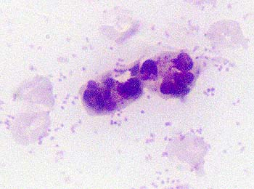
Figure 5. Two degenerative neutrophils with phagocytosed bacteria in abdominocentesis fluid from a cow with traumatic reticuloperitonitis (hardware disease). Bacteria also are scattered in the background of the smear (Wright stain).
Normal cytologic findings do not exclude TRP since cattle tend to wall off inflammation in the peritoneal cavity, making it more difficult to diagnose local peritonitis. Abdominocentesis for evaluation of TRP should be performed at the ruminal-reticular recess to increase the chance of obtaining a diagnostic sample.³ The reference ranges for calves vary significantly from adult cattle. The most notable difference between normal peritoneal samples in calves versus adult cattle is the protein concentration and percentages of neutrophils and eosinophils. Adult ranges should not be used to evaluate peritoneal fluid obtained from younger animals.⁶
Differential Diagnoses
TRP must be distinguished from other causes of peritonitis or abdominal pain for a definitive diagnosis. In febrile animals, the most likely differential diagnosis is a perforating abomasal ulcer. A perforating abomasal ulcer can be distinguished from chronic TRP since a cow with chronic TRP is typically afebrile and has cranial ventral abdominal pain, whereas a cow with a perforating abomasal ulcer typically has mid-abdominal pain. (1) Also, cattle with a perforating abomasal ulcer may show evidence of gastrointestinal leakage, such as plant material, on abdominocentesis, microorganisms, and/or squamous cells in the abdominal fluid. The most likely differential diagnoses for an afebrile animal are indigestion and ketosis. Cows with indigestion or ketosis should not be painful and ketotic cows will have ketones in their urine, as detected by dipstick analysis.¹Overall, the best differentiator of these diseases is total plasma protein levels. Total plasma protein should not be increased in a cow with either indigestion or ketosis and are less severely increased in a cow with a perforating abomasal ulcer.⁵
Complications of TRP
Reticular abscesses are a common complication of TRP. Also, if the foreign body migrates through the diaphragm and into the pericardium, it can cause septic pericarditis and subsequent congestive heart failure. Less common complications include reticular fistulation, vagal indigestion, and diaphragmatic hernia.(1)
Treatment
Since reticular foreign bodies often migrate back into the lumen of the reticulum, conservative treatment can have good results. Conservative treatment consists of instillation of a magnet to recover or immobilize the metal foreign body if the foreign body is composed of magnetic metal. Affected cattle should also receive 3-7 days of systemic antibiotic therapy (penicillin, ceftiofur, ampicillin, or tetracycline), stall rest and other supportive therapy as indicated. Affected cattle should be re-evaluated in 48-72 hours. If a magnet is already in place or conservative therapy is not successful, an exploratory laparotomy/rumenotomy is indicated for removal of the foreign body.(1,2)
Prevention
Prevention of TRP is preferred to either conservative medical treatment or surgery. Although one source does not believe magnets are an effective preventative measure,⁹the majority of clinicians agree that all cattle over one year of age should have a prophylactic magnet placed in the reticulum.(1,2,4) Following oral administration, most magnets do not enter the reticulum directly, but are first deposited in the cranial sac of the rumen before entering the reticulum following ruminal contractions.² Cattle should be kept away from construction sites and crop fields should be monitored for metal debris. Also, processed feed can be passed over magnets to recover any magnetic foreign bodies prior to being fed to cattle.

References
1. Rebhun WC: Diseases of Dairy Cattle. Philadelphia, Williams and Wilkins, 1995, pp. 113-116.
2. Ducharme NG, Fubini SL: Surgery of the Ruminant Forestomach Compartments. In:Fubini SL, Ducharme NG: Farm Animal Surgery. St. Louis, W. B. Saunders Co., 2004, pp. 186-188.
3. House JK, Smith BP, VanMetre DC, Fecteau G, Craychee T, Neves J: Ancillary tests for assessment of the ruminant digestive system. Vet Clin North Am Food Anim Pract 8:203-204, 1992.
4. Ward JL, Ducharme NG: Traumatic reticuloperitonitis in dairy cows. J Am Vet Med Assoc 204:874-877, 1994.
5. Dubensky RA, White ME: The sensitivity, specificity, and predictive value of total plasma protein in the diagnosis of traumatic reticuloperitonitis. Can J Comp Med 47:241-244, 1983.
6. Anderson DE, Cornwell D, Anderson LS, St-Jean G, Desrochers A: Comparative analyses of peritoneal fluid from calves and adult cattle. Am J Vet Res 56:973-976, 1995.
7. Latimer KS, Mahaffey EA, Prasse KW: Duncan & Prasse’s Veterinary Laboratory Medicine: Clinical Pathology, 4th ed. Ames, Iowa State Press, 2003, pp. 68-77, 152-160, 166-167.

