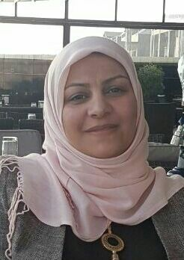
Academic C.V for Lecturer

Personal Details and Contact Details
Name: MUNA HUSSAIN HUSSAN
Place and Date of birth: Baghdad 27/8/1976
Marital Status: Married
Title: Lecturer
Address: Karbala -Iraq
Tel: 007706033151
Email: (munahussen@yahoo.com)

Education and Qualifications
- From (1995) to (2003): Degree (BSc.) in Specialization (veterinary medicine and surgery), College of veterinary medicine-University of Baghdad.
- From (2009) to (2011): Degree (MSc.) in Specialization (Anatomy and Histology), College of veterinary medicine-University of Baghdad.
- From (2012) to (2015): Degree (PhD) in Specialization (Anatomy and Histology), College of veterinary medicine-University of Baghdad.

Relevant Work/Research Experience
- From (2007) to (2013): Lecturer in Ministry of higher education and scientific research, University of Karbala), City (Karbala), Country (Iraq).
- From (2004) to (2007): Experience working and studying in the veterinary field.
- From (2003) to (2006): Veterinarian in veterinary hospital, Ministry of Agricultural, City (Karbala), Country (Iraq).

Skills
- Fluent in Arabic and English, both spoken and written.
- Skilled at laboratory research and class facilitation.
- Computer skills: Microsoft Word, Power Point, excel.
- Very organized and meticulous.

Posts of responsibility
- Chair associate of anatomy and histology department, College of veterinary medicine-University of Karbala.
- Lecturer of anatomy and histology, 1st-2nd stage.

Researches
- Spermatogenesis and Spermiogensis in local breed Iraqi Cock.
- Growth of parasite Giardia Lamblia study in modified media TY1-33.
- Growth of parasite Entamoeba Histolytica study in media HSP.

- The Histomorphological Study of Syrinx of Black Francolin (Francolinus francolinus) in Iraq (2015)

- Histlolgical and histochemical study of the large intestine of camel.(2016)

Researches under study
- Histo- morphological study of small intestine of local and wild birds.
- Histo- morphological study of olfactory region of adult dogs.
- Histo- morphological study of respiratory system of embryo rabbit.

Conferences and seminars
- 1st scientific conference, college of veterinary medicine, university of Karbala in the April 2012.
- Interests/hobbies
- Interest of reading the recent topics of histological research.
- My favorite hobbies are reading different topics books.
*** Certification of contributor of conference international fa2nd of biological science in faculty of education for women/ University of Kufa.
**** Certification of contributor of lecture of invertebrates about the mange scabies in college of education pure science.

